

**INFORMATION TECHNOLOGY DEPARTMENT**

**XAVIER INSTITUTE OF ENGINEERING**

**UNIVERSITY OF MUMBAI**

**2021 – 2022**

**XAVIER INSTITUTE OF ENGINEERING**

**MAHIM CAUSEWAY, MAHIM, MUMBAI - 400016.**

**COLLEGE SPACE**

SUBMITTED IN PARTIAL FULFILLMENT OF THE REQUIREMENTS OF THE DEGREE OF

**BACHELOR OF ENGINEERING**

IN

**INFORMATION TECHNOLOGY**

BY

**UTTAM PANDEY**

**SANDEEP SAHANI**

**DHRUYASH MAHALE**

UNDER THE GUIDANCE OF

**PROF. MARTINA D’SOUZA**

(Department of Information Technology)

**CERTIFICATE**

This to certify that

1. UTTAM PANDEY (201903034)
2. SANDEEP SAHANI (201903040)
3. DHRUYASH MAHALE (201903058)

Have satisfactorily carried out the MINI-PROJECT work titled “**COLLEGE SPACE”** in partial fulfillment of the degree of Bachelor of Engineering as laid down by the University of Mumbai during the academic year 2020-2021.

**Prof. Martina D’souza**

**Internal Examiner**

**External Examiner**

**Date: 18-10-2021**

**Place: MAHIM, MUMBAI**

**DECLARATION**

I declare that this written submission represents my ideas in my own words and where others’

Ideas or words have been included, I have adequately cited and referenced the original sources.

I also declare that I have adhered to all the principles of academic honesty and integrity and have not misrepresented or fabricated or falsified any idea/data/fact/source in my submission.

I understand that any violation of the above will be cause for disciplinary action by the Institute and can also evoke penal action from the sources which thus have not been properly cited or from whom proper permission have not been taken when needed.

Uttam pandey (201903034) -------------------------------

Sandeep Sahani (201903040) -------------------------------

Dhruyash Mahale (201903058) -------------------------------

Date:18-10-2021

**TABLE OF CONTENTS**

|  |  |  |
| --- | --- | --- |
| **SR.NO** | **TOPIC** | **PAGE NO.** |
| A. | LIST OF FIGURES | i |
| B. | LIST OF TABLES | ii |
| C. | ACKNOWLEDGEMENT | iii |
| D. | LAB OUTCOMES | iv |
|  | Rubric page for LO1,LO2, LO3,LO4 |  |
|  |  |  |
| 1. | Introduction   1. Need for developing the website. 2. Problem Definition Aims and Objectives | 9  9 |
|  |  |
| 1. Scope of the project | 9 |
| 4. Features of the project | 9 |
| 1. Constraints on Project. | 10 |
| 1. GUI of webpages | 10,11,12,14,15 |
| 1.8      Test Cases/ Validation | 16 |
| 2. | Implementation Methodology    2.1 Design | 17 |
| 2.1.1.Block diagram, / Flowchart of propose system hardware, Software Requirements. | 18 |
| 2.3 ER Diagram for the website | 19, |
| 2.4database Connectivity    2.5 Code    2.6 Steps to Launch the website on Internet. | 20  20  21 |
| 3 | REFERENCES | 21 |

**LIST OF FIGURES**

|  |  |  |
| --- | --- | --- |
| **SR NO.** | **FIGURE CAPTION** | **PAGE NO.** |
| Fig(1) | Login Page | 10 |
| Fig(2) | SignUp Page | 11 |
| Fig(3) | Main Page | 12 |
| Fig(4) | Upload Notes/Books | 12 |
| Fig(5) | Echo document uploaded SuccessFully | 13 |
| Fig(6) | Uploaded Notes/Book | 13 |
| Fig(7) | Uploading Annoucement | 14 |
| Fig(8) | Uploaded Annoucement | 14 |
| Fig(9) | Uploading Question Paper | 15 |
| Fig(10) | Uploaded Question Paper | 15 |
| Fig(11) | Validation Email ID | 16 |
| Fig(12) | Validation of ID Password | 16 |
| Fig(13) | Flow Chart | 17 |
| Fig(14) | ER Diagram | 19 |
| Fig(15) | Database Connectivity | 19 |

**i**

**LIST OF TABLES**

|  |  |  |
| --- | --- | --- |
| **SR NO.** | **TABLE TITLE** | **PAGE NO.** |
| 1 | Software Interface | 18 |

ii

**Acknowledgement**

We would like to thank Fr. Dr. John Rose S.J (Director of XIE) for providing us with such an environment so as to achieve goals of our project and supporting us constantly.

We express our sincere gratitude to our Honorable Principal Mr. Y.D.Venkatesh for encouragement and facilities provided to us.

We would like to place on record our deep sense of gratitude to Prof.ChhayaNarvekar,Head of Dept Of Information Technology, Xavier Institute of Engineering, Mahim, Mumbai, for her generous guidance help and useful suggestions.

With deep sense of gratitude we acknowledge the guidance of our project guide Prof Martina D’souza. The time-to-time assistance and encouragement by her has played an important role in the development of our project.

We would also like to thank our entire Information Technology staff who have willingly cooperated with us in resolving our queries and providing us all the required facilities on time.

Uttam pandey -----------------------------

Sandeep Sahani -----------------------------

Dhruyash Mahale             -----------------------------

iii

Here Attach the New LO

Following is the old LO

|  |  |  |  |  |  |  |  |  |  |
| --- | --- | --- | --- | --- | --- | --- | --- | --- | --- |
| Course Code | Course Name | Examination Scheme | | | | | | | |
| Internal Assessment | | | End Sem Exam | Term Work | Oral & Practical | Oral | Total |
| Test 1 | Test 2 | Avg |
| ITL501 | Internet Programming Lab | - | - | - | - | 25 | 25 | - | 50 |

**Term Work (25)** = Miniproject(15) + Assignment(05) + Attendance(05)

**Bloom’s Taxonomy Level (BTL):**

**1: *Knowledge*  2: *Understand*  3: *Apply*  4: *Analyse*  5: *Evaluate*  6: *Create***

**Lab Outcome: Students will be able to :**

|  |  |  |
| --- | --- | --- |
| 1 | Design a basic website using HTML5 and CSS3 to demonstrate responsive web design and implement dynamic web pages with validation using JavaScript objects by applying different event handling mechanism. | BTL: 6 |
| 2 | Use AJAX Programming Technique to develop RIA | BTL: 3 |
| 3 | Develop simple web application using server side PHP programming and Database Connectivity using MySQL. | BTL:6 |
| 4 | Construct/Build well-formed XML Document and implement Web Service using Java. | BTL:6 |
| 5 | Describe/Demonstrate simple web application using Python Django Framework. | BTL:1,2 |

iv

**1. INTRODUCTION:**

This section is written to provide general information about our product “College Space”. The main objective of our product is to maintain information about students and the data they consume on daily basis for their college work. The information is stored on the website is for student and for the teacher’s were they can share their study material through this platform on the Internet.

**1.1 Need for developing the website.**

The purpose of this document is to build an online website to ease the process of finding study materail’s.

* 1. **Problem Definition Aims and Objectives**

**1.3 Scope of the project**

The scope of our project **College Space** is where students can get the reference books, various **notebooks**, Quiz references and student will Also will notify with latest **Announcements.**

* 1. **Features of the project**
* The website is responsive, platform independent and user friendly keeping in mind the user classes the design is laid out for.

* This product is usefull for the student to get all the information from one website such that they can get notebook for reference question paper and many more things.
  1. **Constraints on Project**

The design time constraints are:

* The software package should be designed so as to handle the access by Admin Only.
* This software is currently in under process.
  1. **GUI of Webpage**

**Login Page:** A login page is a web page or an entry page to a website that requires user identification and authentication, regularly performed by entering a username and password combination. Logins may provide access to an entire site or part of a website. Some websites use cookies to track users during their logged in sessions.

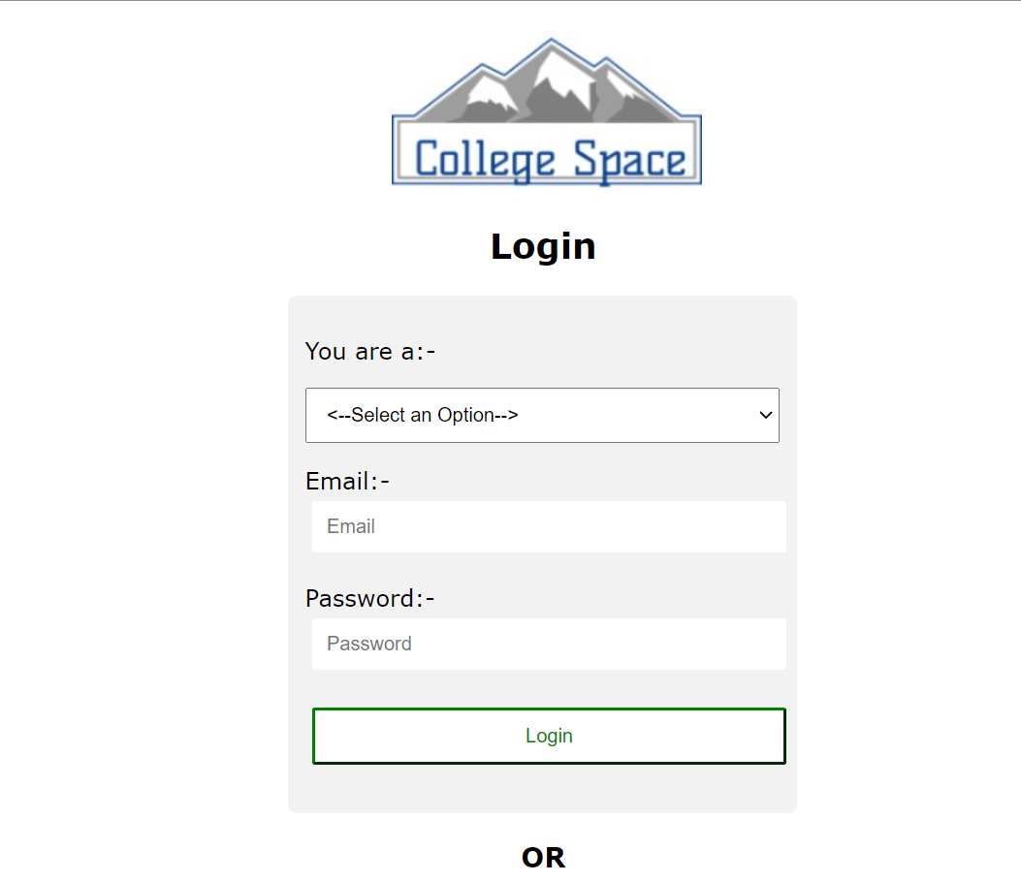

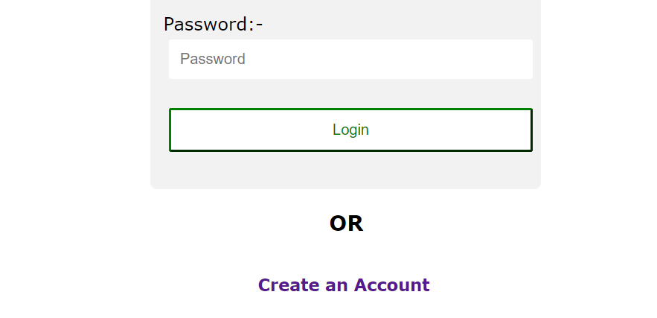

Fig(1) Login Page

**SignUp Page:** A signup page (also known as a registration page) enables users and organizations to independently register and gain access to your system. It is common to have multiple signup pages depending on the types of people and organizations you want to register.

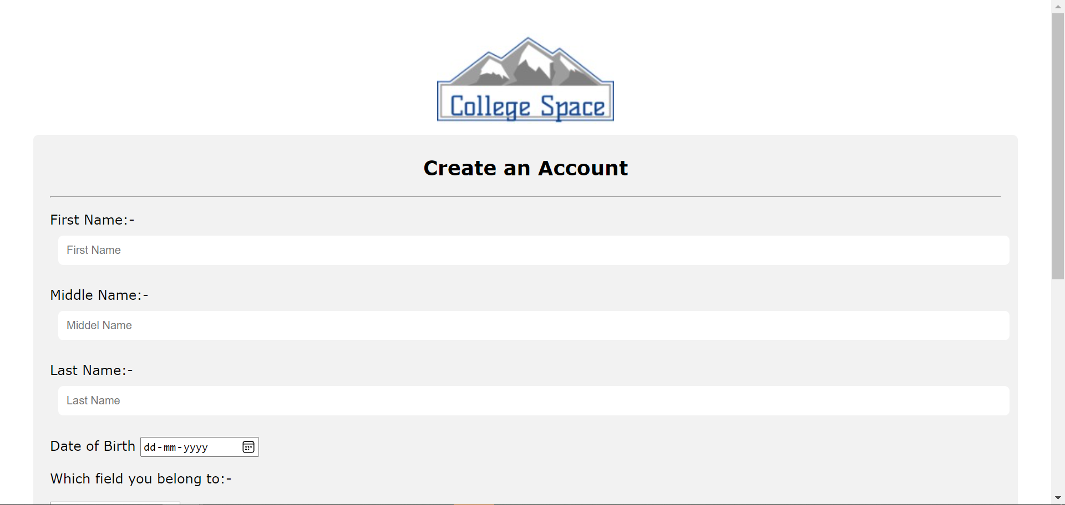

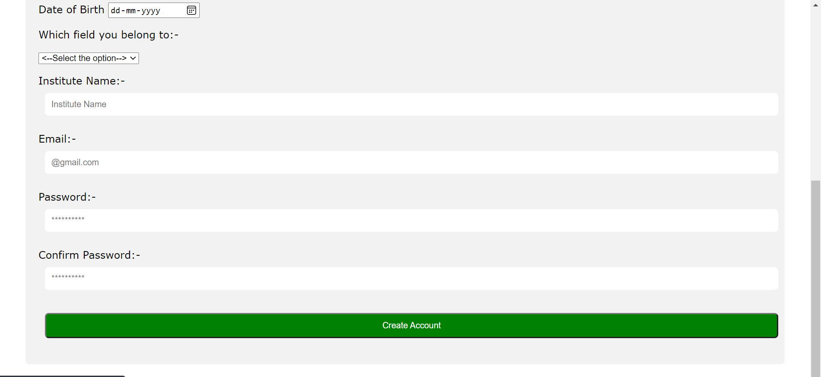

Fig(2) SignUp Page

**Main Page:** The page typically encountered first on a website that usually contains links to the other pages of the site

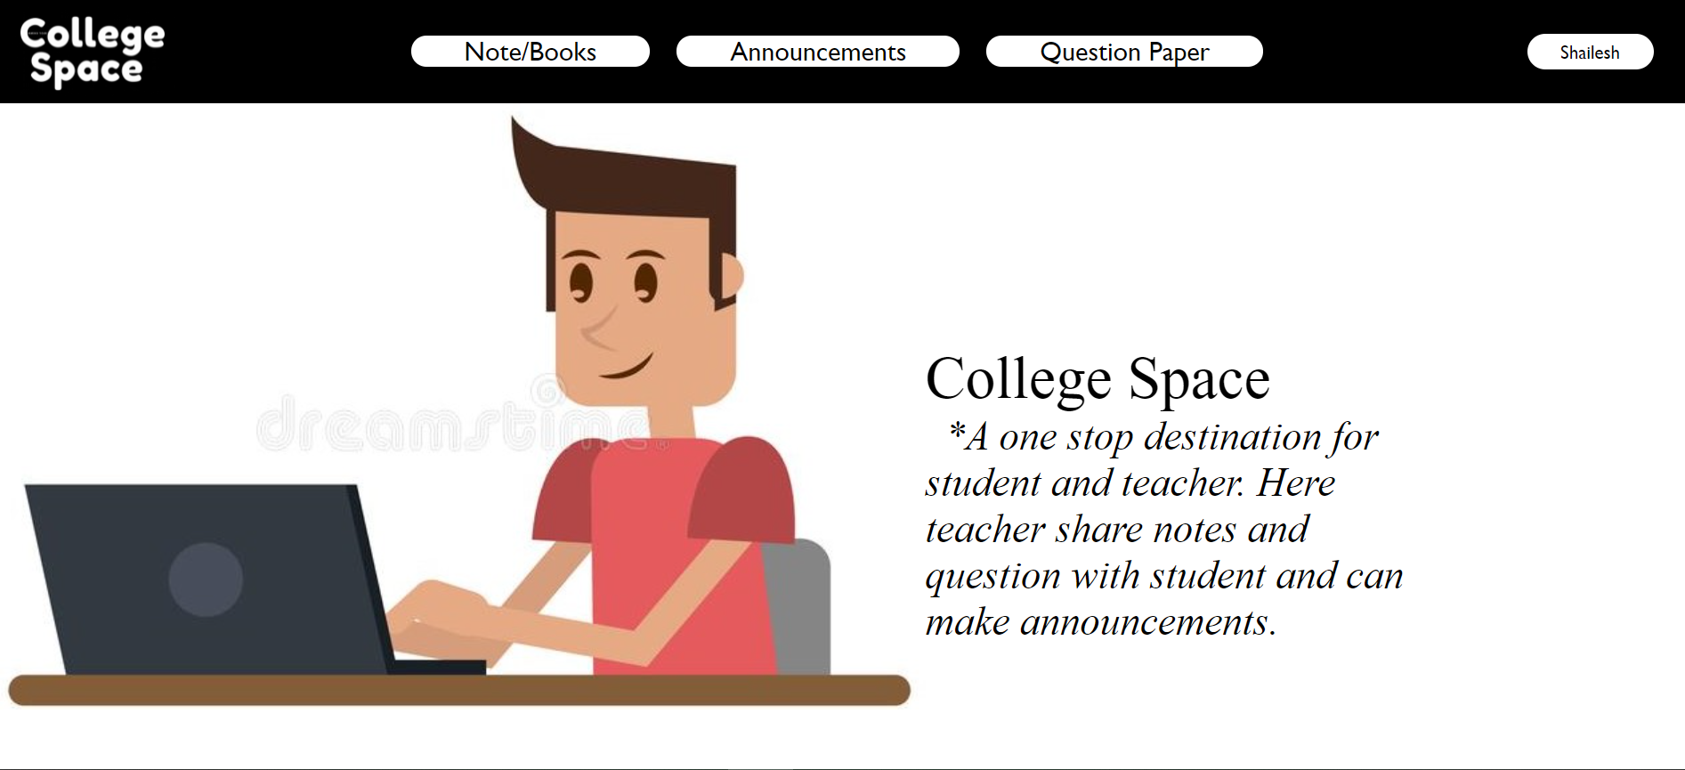

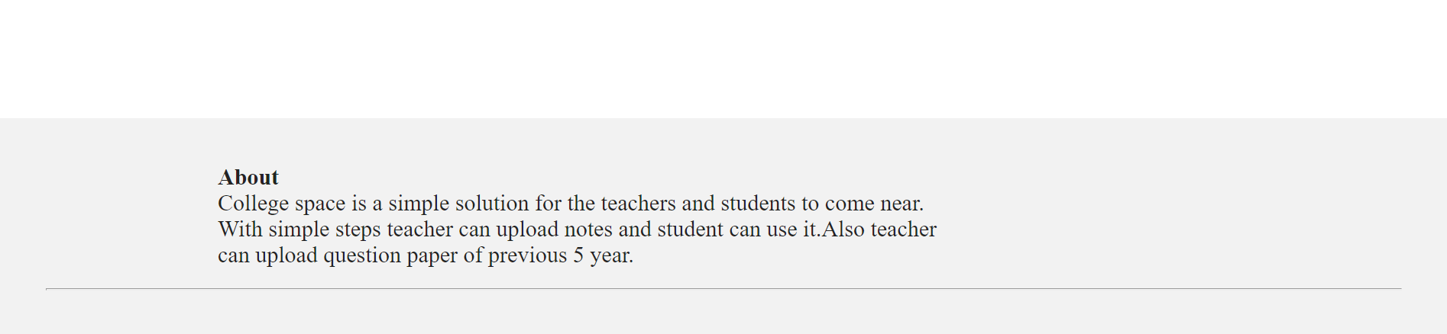

Fig(3) Main Page

**Upload Notes/Books:**

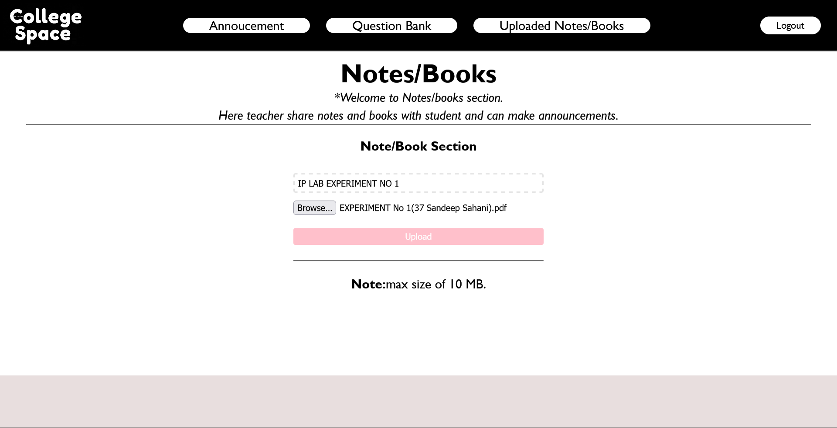

Fig(4) Upload Notes/Books

**Notification for document uploaded SuccessFully :**

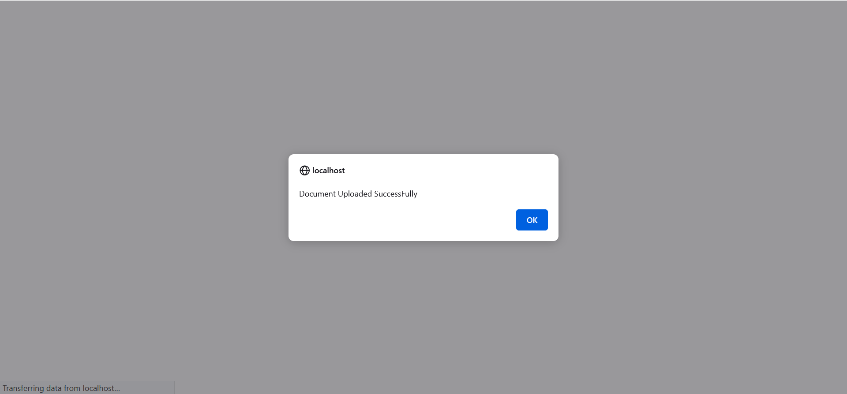

Fig(5) Echo document uploaded SuccessFully

**Uploaded Notes/Books:**

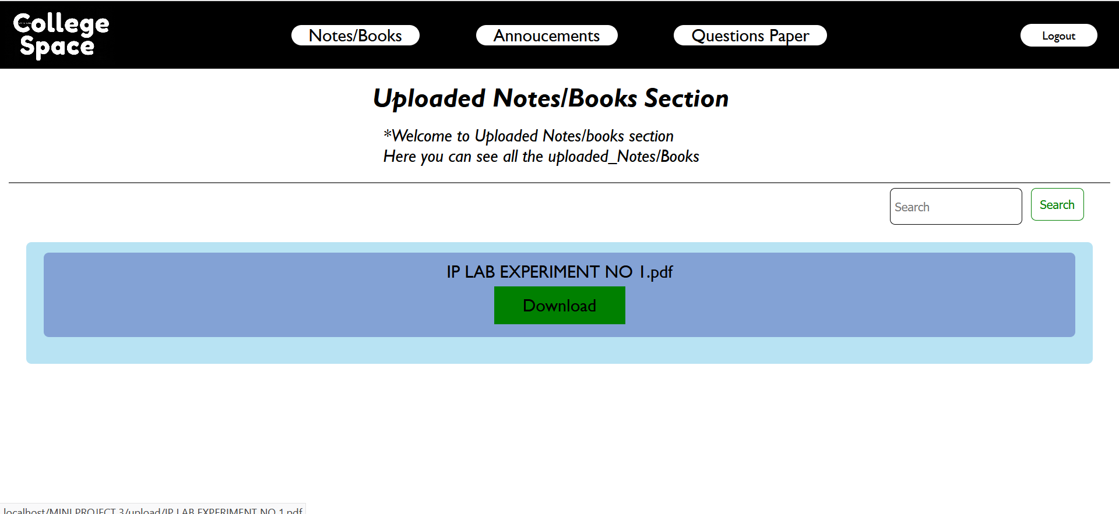

Fig(6) Uploaded Notes/Book

**Announcement:**

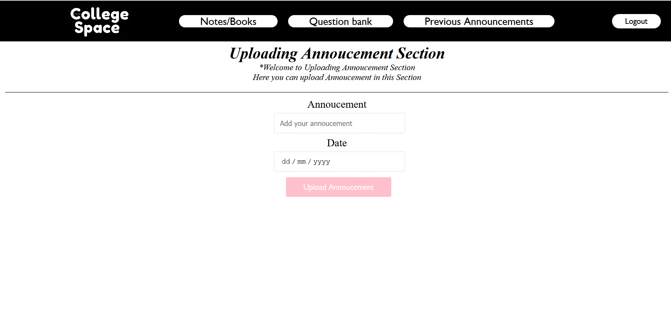

Fig(7) Uploading Annoucement

**Previous Annoucement:**

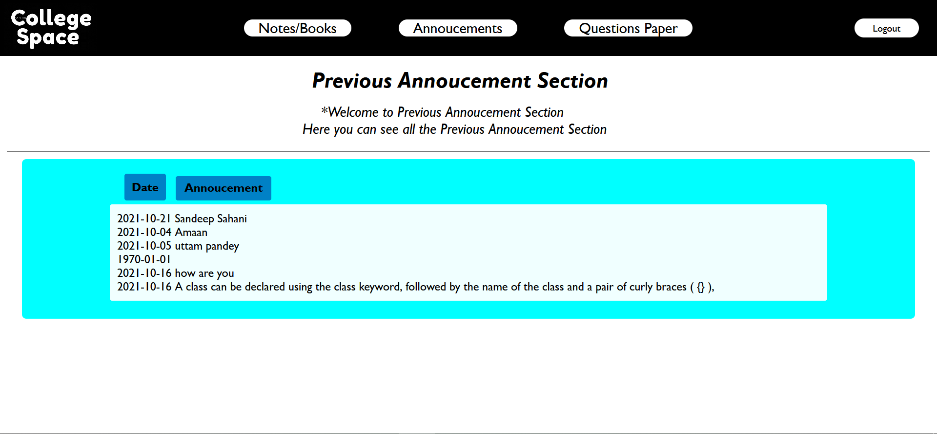

Fig(8) Uploaded Annoucement

**Upload Question Paper:**

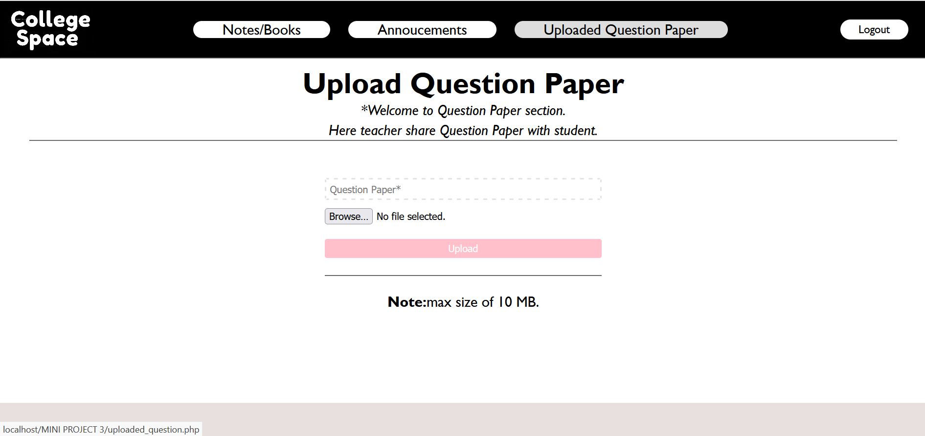

Fig(9) Uploading Question Paper

**Uploaded Question Paper:**

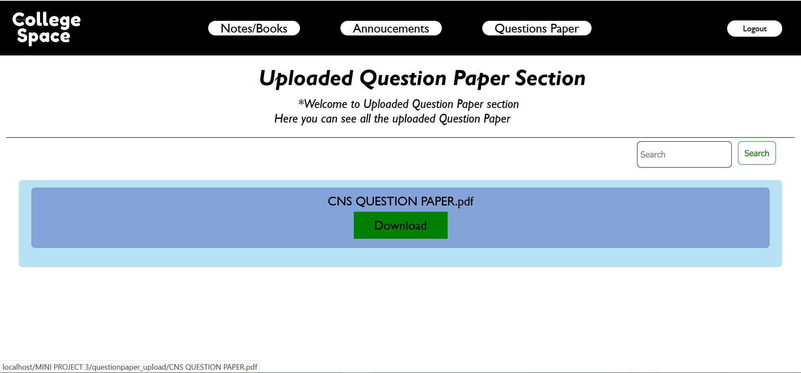

Fig(10) Uploaded Question Paper

**Test Cases/ Validation :**  You can refer to these test cases while creating test cases for login page of your application under test.

As we know that the focus here is to cover the different features to be tested instead of the creation of formal test cases, so basically we will be presenting test scenarios here. If you want to know the exact difference between test cases and test scenarios,

**When Email ID is not proper:**

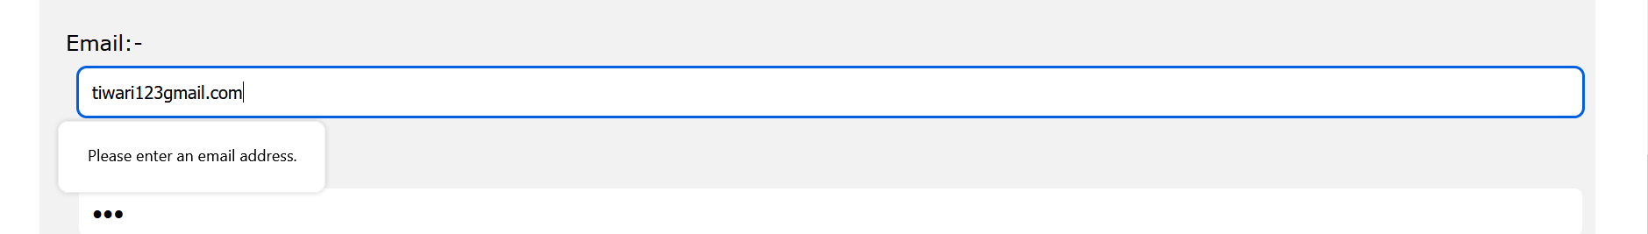

Fig(11) Validation Email ID

**When Login Detail is not correct:**

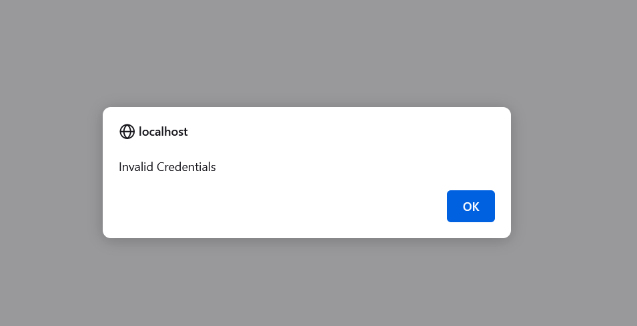

Fig(12) Validation of ID Password

**2. Implementation Methodology**

**2.1 Design :** Software design is the process of envisioning and defining software solutions to one or more sets of problems. One of the main components of software design is the [software requirements analysis](https://en.wikipedia.org/wiki/Software_requirements_analysis).

**2.1.1.Block diagram, / Flowchart of proposed   system :** A block diagram is a diagram of a system in which the principal parts or functions are represented by blocks connected by lines that show the relationships of the blocks. They are heavily used in engineering in hardware design, electronic design, software design, and process flow diagrams.

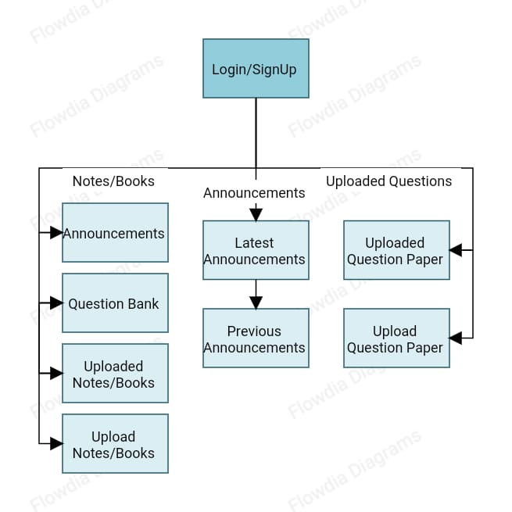

Fig(13) Flow Chart

**2.2 Hardware, Software Requirements.**

**Hardware Interface:**

* Since the application must run over the internet, all the hardware shall require to connect internet will be hardware interface for the system. As for e.g., Modem, WAN — LAN, Ethernet Cross-Cable.

**Software Interface:**

**Front end:**

|  |  |
| --- | --- |
| Layout | HTML5 |
| Designing | CSS3 |
| Scripting Language | JavaScript |

**Back end: PhpMyAdmin**

|  |  |
| --- | --- |
| Storage | phpMyAdmin |

(1) Software Interface

**2.3 ER Diagram for the website:** ER Model is used to model the logical view of the system from data perspective which consists of these components.

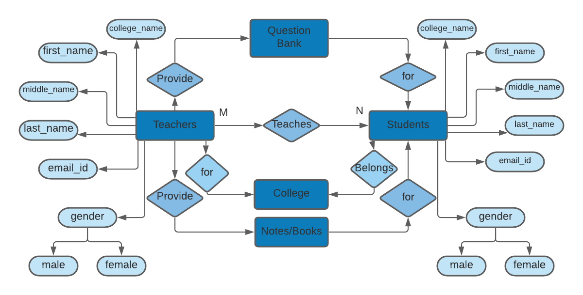

**Fig(14) ER Diagram**

**2.4 Database Connectivity :** A database connection is a facility in [computer science](https://en.wikipedia.org/wiki/Computer_science) that allows [client](https://en.wikipedia.org/wiki/Client_(computing)) software to talk to [database server](https://en.wikipedia.org/wiki/Database_server) software, whether on the same machine or not. A connection is required to send [commands](https://en.wikipedia.org/wiki/Command_(computing)) and receive answers, usually in the form of a result set.

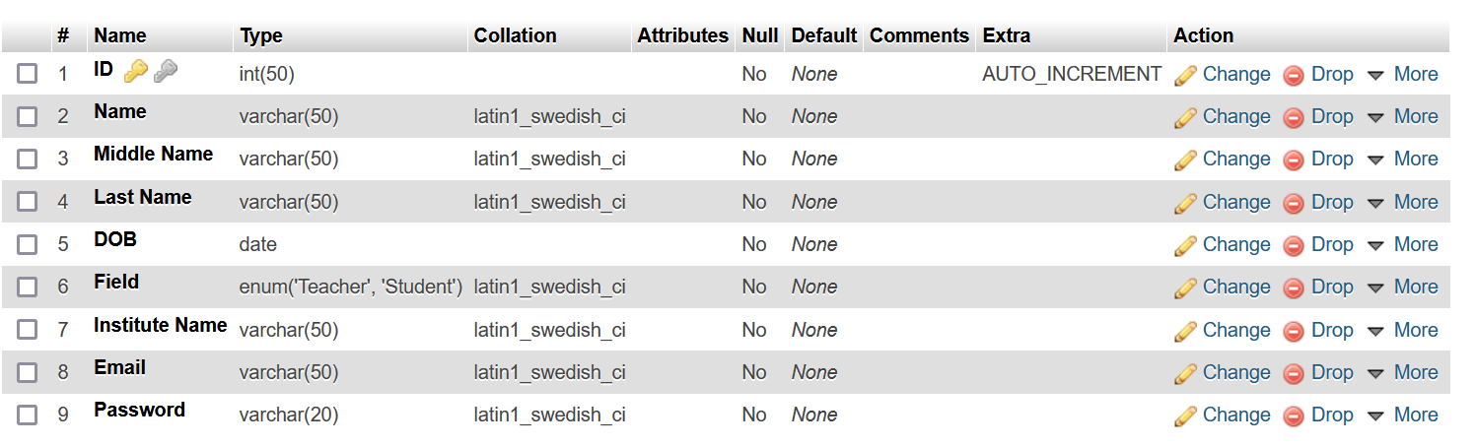

Fig(15) Database Connectivity

**2.5 Code:** Code, in a general sense, is the language understood by the computer. Computers don't understand natural language. As such the human language has to be converted into a set of "words" that are understood by the computer.

**main.php**

<?php

session_start();

if (!isset( $_SESSION['authorized-user']))

    {

    header('Location: /MINI PROJECT 3/Login_Page.html');

    exit();

    }

?>

<!DOCTYPE html>

<html lang="en">

<head>

    <meta charset="UTF-8">

    <meta http-equiv="X-UA-Compatible" content="IE=edge">

    <meta name="viewport" content="width=device-width, initial-scale=1.0">

    <title>COLLEGE SPACE.com</title>

    <link rel="stylesheet" href="mini_project.css">

</head>

<body>

   <header>

       <img src="image/college.gif" alt="" height="10%" width="10%">

       <nav>

           <ul class="nav_links">

               <li><a href="Note_Books.html" class="anker">Note/Books</a>

                <li><a href="Annocement_page.html" class="anker">Announcements</a>

                <li><a href="Question_Paper.html" class="anker">Question Paper</a></li>

               </li>

           </ul>

       </nav>

        <a href="logout.php" class="cta" ><button><?php echo $_SESSION['name'];?></button></a>

   </header>

   <nav>

       <img src="image/s.jpg" alt="" class="imag" align="left" height="600">

   </nav>

   <div>

       <h2>College Space</h2>&nbsp;

       <em>*A one stop destination for student and teacher.</em>

       <em>Here teacher share notes and question with student and can make announcements.</em>

   </div>

   <footer>

       <h4 class="last">About</h4>

      <p class="last">College space is a simple solution for the teachers and students to come near.</p>

      <p class="last">With simple steps teacher can upload notes and student can use it.Also teacher</p>

      <p class="last">can upload question paper of previous 5 year.</p>&nbsp;

      <hr>

    </footer>

</body>

</html>

* 1. **Steps to Launch the website on Internet.**

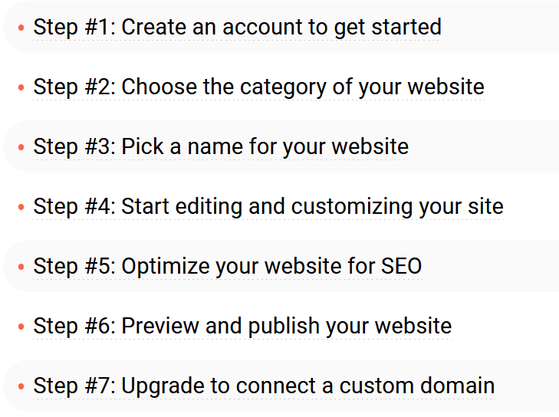

**3. REFERENCES**

[1]College Space: [https://collegespace.netlify.app**/**](https://collegespace.netlify.app/%20)

[2] Stackoverflow